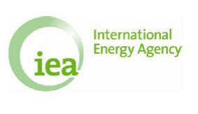

IEA Implementing Agreement
on Co-operation on the Large Tokamak Facilities
and
IEA Implementing Agreement
for Co-operation on Tokamak Programmes

End-of-Term Report for the period 2006-2011

Table of Contents

Page
Introduction 1
1. Strategic direction 1

2. Scope 2
  - Activities 2
2.2 Funding 6
2.3 Membership 6

3. Contractual and management requirements 9
3.1 Objectives 9
3.2 Executive committee meetings 9
3.3 Annual reports 12
3.4 IA legal text 12

4. Contribution to technology evolution / progress 12
4.1 Progress made by Task activities 12
4.2 Progress in each Contracting Party supported
and enhanced by this cooperation 13
5. Policy relevance 14

6. Contribution to information dissemination 14
6.1 Increased visibility through IEA LT Website 14
6.2 Publications during this term 15

7. Outreach to IEA non-Member countries 15

8. Added value 16

Introduction
The IEA Implementing Agreement on “Co-operation on the Large Tokamak Facilities”, the LT-IA, began on January 15, 2001 as an amendment and extension of the IEA Implementing Agreement on “Cooperation among the Three Large Tokamak Facilities (JET, JT-60 and TFTR)” signed on January 15, 1986. The LT-IA reflects the major changes in the programs of the three Contracting Parties, which include the shutdown of TFTR in the U.S. in 1997, and the transfer of the use of the JET Facilities from the JET Joint Undertaking to the European Fusion Development Agreement (EFDA) on January 1, 2000. The current 5-year term began on January 15, 2006 as an extension of the LT-IA. Korea joined the IA on February 5, 2010, and the IA was amended to become the IEA Implementing Agreement for “Co-operation on Tokamak Programmes”, the CTP-IA, on June 15, 2010, thus providing the opportunity for including the tokamak programmes of all the ITER Members. The Institute for Plasma Research (India) joined the CTP-IA on 11th April 2011.

- Strategic direction

The world fusion research program entered a new phase with the construction of ITER, which will be followed by an operation phase that includes a controlled DT burn with Q=10 or more, and the investigation of the feasibility of steady state operation. During the preparation phase for the ITER Implementation Agreement and the ITER construction phase, the confirmation and extension of operating scenarios for implementation in the ITER program are key research elements for the existing large tokamak facilities. The importance of such a supporting program was stressed during the ITER negotiation process. The CTP-IA is one of main vehicles for such cooperation, contributing to the development of the tokamak for ITER and for the generation of devices that will follow ITER through tokamak concept improvement.

This cooperation is a long standing IA for demonstrating and improving tokamak confinement configuration through large tokamak experiments since 1986. The period of this cooperation can be categorized in three phases:

Phase I: 1986 - 1995: Cooperation to achieve mission of the three Large Tokamaks
In this phase, cooperation focused on achieving the mission of the three large tokamaks, such as equivalent break-even and/or significant fusion power. The areas of cooperation in physics were equilibrium control, confinement improvement, transport, stability, plasma heating, wall conditioning and impurity control, and in technology were tokamak device studies, diagnostics, heating systems, and power and control systems.

Phase II: 1995–2005: Cooperation to provide database for ITER construction and concept development of Advanced Tokamak
The areas of cooperation in this phase were DT operation, energetic particle driven instabilities (such as Alfven Eigenmodes), helium ash exhaust, edge and internal transport barriers, characterization and mitigation of disruptions and tritium plant operation, waste management in fusion devices, performance extension of plasma heating systems, etc..

Phase III: 2005-2011: Cooperation to extend ITER operation scenarios and further development of Advanced Tokamak
Before the start of ITER operation, the large tokamaks continued to be key drivers for advancing tokamak physics and the tokamak concept, with strong cooperation with the other fusion-related IAs. During this Phase, confirmation and extension of ITER operation scenarios and the further development of the Advanced Tokamak (AT) were pursued.

During Phase II, multi-machine joint experiments between not only JT-60 and JET but also other tokamaks were recognized as important for their contribution to ITER. Therefore, coordination with other tokamak-related IAs started in 2002, with the planning and implementation of joint experiments for ITER.

During Phase III, contributions to ITER were optimized by strengthening the coordination with other bodies. In addition, various tools were planned and implemented jointly to maximize the productivity of the large tokamak facilities. Furthermore, the LT-IA led the international tokamak community in implementing the High Priority Research Tasks identified by the International Tokamak Physics Activity (ITPA), which coordinates tokamak physics activities among domestic programs of the ITER Members and operates under the ITER auspices since July 2008. Thus, the scientific content of the activities of the LT-IA and now the CTP-IA has been enriched for the benefit of ITER by the broader participation of the tokamak programs in the CTP-IA.

2. Scope
The first activity carried out is the exchange of information between the Contracting Parties in the areas of:
(i) Experimental program plans for the Large Tokamak Facilities;
(ii) Design and planning of experiments on the Large Tokamaks to contribute to the data base for the next-generation tokamak devices;
(iii) Experimental, theoretical and technical studies in: (a) Plasma equilibrium and stability; (b) Energy and particle transport; (c) Plasma heating; (d) Plasma-wall interaction; (e) Deuterium-tritium burning; (f) Plasma current drive; (g) Plasma fuelling; (h) Plasma diagnostics; (i) Other areas as mutually agreed;
(iv) Management and operation of facilities related to: (a) Operating procedures; (b) Maintenance procedures; (c) Safety rules; (d) Inventory control; (e) Documentation procedures; (f) Control and management of operating records; (g) Computer control systems; (h) Other areas as mutually agreed.

The second activity carried out is the assignment of scientists, engineers and other technical experts to work at the facilities of the Contracting Parties in the areas of tokamak physics, systems engineering and project management, in accordance with agreements between the assigning and receiving Contracting Parties.

The third activity is the organization of selected Workshops in the areas referred to under the first activity above.

The second and third activities have been carried out also in support of the first activity. Some of the collaborations have involved technology issues such as tritium handling, development of Negative Neutral Beam Injection (N-NBI) and radiofrequency (RF) heating systems, and plasma facing components that were coordinated with other IEA fusion technology IAs. To carry out these activities efficiently, they have been undertaken in coordination with the Topical Groups of the International Tokamak Physics Activity (ITPA).

  - Activities
Information exchange has been ensured through Personnel Assignments and Workshops. Televideo conferencing facilities were also used for communication between the participating parties.

(a) Personal Assignments
In order to exchange information on the Large Tokamak Facilities between the Contracting Parties, a large number of personnel assignments have been carried out. The total number of personnel assignments carried out during the period between January 2005 and December 2011 was 146. The details are summarized in Table 1.

Table 1 The number of Workshops and Personnel Assignments organized under the LT-IA and CTP-IA.

 | 2006 | 2007 | 2008 | 2009 | 2010 | 2011 | total
Workshops | 2 | 2 | 2 | 2 | 1 | 1 | 10
Personnel Assignments (Total) | 21 | 25 | 27 | 25 | 22 | 26 | 146
(1) P (Participation: more than 4 weeks) | 0 | 1 | 0 | 0 | 0 | 0 | 1
EU ( US | 0 | 0 | 0 | 0 | 0 | 0 | 0
EU ( JP | 0 | 0 | 0 | 0 | 0 | 0 | 0
JP → US | 0 | 0 | 0 | 0 | 0 | 0 | 0
JP → JET | 0 | 1 | 0 | 0 | 0 | 0 | 1
US → JP | 0 | 0 | 0 | 0 | 0 | 0 | 0
US → JET | 0 | 0 | 0 | 0 | 0 | 0 | 0
KSTAR <--> JET,JT-60, U.S. | NA | NA | NA | NA | 0 | 0 | 0
(2) R (Review Tour: less than 4 weeks) | 21 | 24 | 27 | 25 | 22 | 26 | 145
EU → US | 3 | 5 | 4 | 1 | 1 | 12 | 26
EU → JP | 1 | 3 | 3 | 1 | 3 | 0 | 11
JP → US | 0 | 0 | 0 | 1 | 2 | 3 | 6
JP → EU | 3 | 1 | 4 | 1 | 3 | 1 | 13
US → JP | 4 | 10 | 7 | 5 | 3 | 0 | 29
US ( EU | 10 | 5 | 9 | 16 | 5 | 1 | 46
KO ( EU | n.a | n.a | n.a | n.a | 0 | 6 | 6
US → KO | n.a | n.a | n.a | n.a | 5 | 3 | 8

(b) Workshops

I. Outline of the Workshops
The Large Tokamak Workshops have played a core role in world fusion collaboration. The purpose of the activity is to provide fundamental contributions to ITER and a tokamak demonstration reactor. Towards this aim, a wide range of fusion research fields have been covered in Workshops. Reflecting progress in world fusion research and considering the impact on ITER, key physics and engineering areas have been selected as the subjects of the Workshops. The results from medium/small sized tokamaks, helical devices, modelling and theory have been reported, in addition to results from the large tokamaks. These Workshops were useful for evaluating and improving the research activities in the large tokamaks and in the wider fusion programs worldwide.

From 2006 to 2009, 8 workshops were held on key physics and engineering issues, as shown in Table 2. The total number of participants in these Workshops was 265. Since these Workshops were open to the worldwide fusion community, a number of specialists (33 on average) contributed to progress in these research fields. At each Workshop, there was an exchange of information, comparison of research results, identification of the key physics processes and techniques, and discussions on the new large tokamak experiments including collaborative proposals.

In 2010 and 2011, two Workshops were organised (W72) and (W73), on Coordination of Tokamak Programs on Implementation of the ITPA Coordinated Research Recommendations. Regarding the workshops planned for 2012, it was commented that it is difficult to organise further workshops in even years in addition to the already planned joint experiments workshop in Cadarache in December 2012. Nevertheless, it was suggested to organise a workshop on ELMs in 2013.

Table 2 List of Workshops held under the LT-IA and CTP-IA
(15 January 2006 to 31 December 2011)
No. | Title
No. | Date | Location | No. of Participants
W64 | Edge Transport in Fusion Plasmas
W64 | 11-13 Sep. 2006 | Krakow, Poland | 30
W65 | Fifth Joint workshop of Large Tokamak (W65), Poloidal Divertor and Textor IA's on "Implementation of the ITPA Coordinated Research Recommendations"
W65 | 30 Nov. - 1 Dec. 2006 | JAEA, Naka | 33
W66 | 6th Joint WS of LT (W66) PD and Textor IA's on "Implementation of  the ITPA Coordinated Research Recommendations"
W66 | 29 - 30 Nov. 2007 | EFDA-JET, UK | 26
W67 | The 11th Meeting of the ITPA MHD Topical Group, IEA Large Tokamak workshop on "Control of ELMs and RWM"(W67), US-Japan workshop on "MHD Behavior and Control of Burning Plasma"
W67 | 25-29 Feb. 2008 | JAEA, Naka | 65
W68 | Development of high βN scenarios for ITER
W68 | 24-25 June 2008 | General Atomics, California (USA) | 29
W69 | Seventh IEA Large Tokamak Workshop (W69) on “Implementation of the ITPA Coordinated Research Recommendations” Joint Workshop of Large Tokamak, Poloidal Divertor and Plasma Wall Interactions in TEXTOR IAs
W69 | 11-13 Dec. 2008 | MIT Plasma Science and Fusion Center (USA) | 38
W70 | Key ITER disruption issues
W70 | 7 - 9 Oct. 2009 | EFDA-JET, UK | 42
W71 | 8th joint WS of LT, PD and Textor IA's on "Implementation of the ITPA Coordinated Research Recommendations"
W71 | 15-16 Dec. 2009 | NFRI, Korea | 31
W72 | The First IEA Coordination of Tokamak Programs Meeting on "Implementation of the ITPA Coordinated Research Recommendations"
W72 | 13-15 Dec. 2010 | Cadarache, France
W73 | The Second IEA Coordination of Tokamak Programs Meeting on "Implementation of the ITPA Coordinated Research Recommendations"
W73 | 12 -14 Dec. 2011 | Cadarache, France

II. Summary of each Workshop

i) Summary of W65

The 5th annual Workshop for the planning of ITPA/IEA joint experiments to implement the ITPA high priority research tasks was held at JAEA Naka on November 30 and December 1, 2006. About 33 participants attended, including the Executive Committee members of the three tokamak-related IAs, Chairs, Co-Chairs, and some members of the ITPA Coordinating Committee and its Topical Groups, and Leaders or their representatives of ~ 14 tokamak programs in the seven ITER Parties (CN, EU, IN, JA, KO, RF, and US). The previous Workshops for the planning of Joint Experiments were held at MIT, USA (November 2002), Naka, Japan (December 2003), Oxford, UK (December 2004), and General Atomics, USA (November 2005).

F. Romanelli (EFDA) made opening comments as the Chair of the Executive Committee of the LT-IA. P.Gohil (GA), representing T. Taylor (GA), reported briefly on the 4th Workshop. Ron Stambaugh, Chair of the ITPA Coordinating Committee reported on the status of Joint Experiments that were planned at the last meeting. For preparation of the discussion on the joint experiments, the status of the world tokamak devices was presented, including updated information on new hardware capabilities, operating schedules and major topical areas of research programs.

Following the meeting in 2005, 63 joint experiments were active. Among them, new results were obtained in 34 experiments. During the meeting, the seven ITPA Topical Groups proposed 11 new joint experiments and updated their proposed research on the experiments to be continued into 2007. Thus there were 65 joint proposals for the participants to review and plan for CY 2007. The TG Chairs or Co-Chairs provided one page summaries of these proposals, including the progress made previously, and their recommendations for tokamaks that should participate in these experiments to provide the parameter range for the experiments.
These presentations were followed by the comments of the tokamak leaders or their representatives considering their tokamak programs and schedules, and a discussion of the technical details and necessary basis of proposed joint experiments.
The final session was dedicated to a brief review of each proposal, an expression of interest from the tokamak leaders to participate in specific joint experiments, and the identification of the spokes-persons for the joint experiments and the contact persons for each participating tokamak. This activity led to the development of the Joint Experiments Plan for FY 2007. The commitments of some tokamak Programme Leaders required confirmation after Research Forums, or the equivalent processes, for the individual programs had finalized experiment program plans. Most tokamaks were committed to the joint experiments. The tokamaks that had already completed their contributions to the joint experiments were also identified.
The process of developing joint experiments had matured during the previous four years, and most proposals were well-defined and involved well-coordinated joint experiments. These were labelled as ready for Experiments (E). Some proposals (labelled as D) required additional discussions before joint experiments could be proposed. Only a few proposals (labelled as P) covered ongoing programmatic activities, such as compiling a database, with minimal coordination among the participating tokamaks being required.

ii) Summary of W66

The Workshop held on November 29-30, 2007 was the sixth in the series and was held jointly by the three tokamak-related IA’s and ITPA, with the participation of members of the ITER IO. While recognising that the ITPA is the most effective international body in place for generating coordinated experiment plans across a wide range of fusion research topics, the Workshop aimed to stimulate and facilitate increased multi-machine Joint Experiments amongst the various tokamak programmes.
The Workshop was attended by 26 participants, including the Chairs and additional members of the Executive Committees of the three tokamak-related IA’s, the Chair and additional members of the ITPA Coordinating Committee, the Chairs (or their representatives) of the six ITPA TG’s, representatives of the ITER IO, the Programme Leaders representing 11 major world tokamaks; JET, JT-60U, DIII-D, AUG, C-Mod, Tore Supra, TEXTOR, FTU, NSTX, MAST and KSTAR. Representatives of TCV and the Russian, Chinese and Indian tokamaks were unable to attend the Workshop. Specifically, the Workshop:
- reviewed the status of implementation of the ITPA/IEA coordinated experiments among the major world tokamaks;
- discussed new proposals made by the ITPA and which would benefit from coordination of joint experiments among the major world tokamaks; and
- considered the implementation of these proposals on the major world tokamaks and through agreements such as the three tokamak-related IA’s.
An oral report from the last Workshop (Y. Kamada) was followed by a Report from the ITPA Coordinating Committee Chair (R. Stambaugh) on the status of the implementation of the IEA/ITPA Joint Experiments on the various tokamaks during 2007, a Proposal from the ITPA TG’s for new Joint Experiments between the various tokamaks for 2008 (R. Stambaugh) and a Report on the ITER Research Needs (D. Campbell). The Programme Leaders indicated their level of commitment to the new Joint Experiments. In addition, the ITER Principal Deputy Director General (N. Holtkamp) presented the Status of the ITER Project. The Operation plans of the various Facilities were collated by J. Schweinzer on behalf of the Programme Leaders and members of the ITPA Coordinating Committee, which met with members of the ITER FS&T Department.
The coordinated effort which resulted from this Workshop added significant value to the experiments on the individual Facilities, and will result in personnel and, possibly, some hardware exchanges. The commitments made by the various tokamak Programme Leaders were confirmed, and consolidated by R. Stambaugh, after the Workshop.

iii) Summary of W69

The Workshop held on December 11-13, 2008 was the seventh in the series and was held jointly by the three tokamak-related IEA Implementing Agreements (IAs) and the International Tokamak Physics Activity (ITPA). The ITPA has been operating under the ITER auspices since February 27, 2008. The ITER Fusion Science and Technology (FS&T) Department was well represented at the meeting with the attendance of the Deputy Director General (DDG) and the Assistant DDG, and with the participation of several ITER FS&T staff by televideo conferencing from Cadarache. The scope of the Workshop had expanded to include also discussions of a broad range of ITER physics R&D needs, in addition to the planning of Joint Experiments. The Workshop duration was increased by an additional day in order to accommodate the increased scope. While recognizing that the ITPA is the most effective international body in place for generating coordinated experiment plans across a wide range of fusion research topics, the Workshop aimed to stimulate and facilitate increased multi-machine Joint Experiments amongst the various tokamak programmes.
The Workshop was attended by ~ 34 participants on site and 4 by televideo conferencing from Cadarache, including the Chairs and additional members of the Executive Committees of the three tokamak-related IEA IA’s, the Chair and additional members of the ITPA Coordinating Committee, the Chairs (or their representatives) of the six ITPA TG’s, representatives of the ITER IO, the Programme Leaders representing 11 major world tokamaks (JET, JT-60U, DIII-D, AUG, C-Mod, Tore Supra, TEXTOR, FTU, NSTX, MAST and KSTAR). Representatives of TCV and the Russian, Chinese tokamaks were unable to attend the Workshop.

Specifically, the Workshop:
- reviewed the status of implementation of the ITPA/IEA coordinated experiments among the major world tokamaks;
- discussed new proposals made by the ITPA which would benefit from coordination of joint experiments among the major world tokamaks; and
- considered the implementation of these proposals on the major world tokamaks and through agreements such as the three tokamak-related IA’s.
An oral report from the last Workshop (M. Watkins) was followed by a Report from the ITPA Coordinating Committee Chair (R. Stambaugh) on the status of the implementation of the IEA/ITPA Joint Experiments between the various tokamaks for 2007, a Proposal from the ITPA TG’s for new Joint Experiments between the various tokamaks for 2009 (R. Stambaugh) and a Report on the ITER Research Needs (D. Campbell). The Programme Leaders indicated their level of commitment to the new Joint Experiments.
The coordinated effort which resulted from this Workshop added significant value to the experiments on the individual Facilities, and would result in personnel and, possibly, some hardware exchanges. The commitments made by the various tokamak Programme Leaders were confirmed, and consolidated by R. Stambaugh, after the Workshop.

iv) Summary of W71

The Workshop held on December 15-16, 2009 was the eighth in the series and was held jointly by the three tokamak-related IEA Implementing Agreements (IAs) and the International Tokamak Physics Activity (ITPA). The ITPA has been operating under the ITER auspices since July 2008. The ITER Fusion Science and Technology (FS&T) Department was well represented at the Workshop with the attendance of the Deputy Director General (DDG) and the Assistant DDG, and most of ITPA TG chairs or deputy-chairs attended and reported TG activities with the participation of two TG spokes-persons by televideo conferencing from San Diego and Naka. The scope of the Workshop included discussions of a broad range of ITER physics R&D needs in addition to the planning of Joint Experiments. While recognizing that the ITPA is the most effective international body in place for generating coordinated experiment plans across a wide range of fusion research topics, the Workshop aimed to stimulate and facilitate increased multi-machine Joint Experiments amongst the various tokamak programmes.
The Workshop was attended by ~ 29 participants on site and 2 by televideo conferencing from San Diego and Naka, including the Chairs (or Deputy Chairs) and additional ExCom members of the three tokamak-related IA’s, the Chair and additional members of the ITPA Coordinating Committee, the Chairs (or their representatives) of the seven ITPA TG’s, representatives of the ITER IO, the Programme Leaders representing 12 major world tokamaks (JET, JT-60U, DIII-D, AUG, C-Mod, TCV, Tore Supra, TEXTOR, NSTX, MAST, EAST and KSTAR). Representatives of FTU and the Russian, HL-2A tokamaks were unable to attend the Workshop. Specifically, the Workshop:
- reviewed the status of implementation of the ITPA/IEA coordinated experiments among the major world tokamaks;
- discussed new proposals made by the ITPA which would benefit from coordination of joint experiments among the major world tokamaks; and
- considered the implementation of these proposals on the major world tokamaks and through agreements such as the three tokamak related IA’s.
An oral report from the last Workshop (E. Oktay) was followed by a Report from the ITPA Coordinating Committee Chair (R. Stambaugh) on the status of the implementation of the IEA/ITPA Joint Experiments between the various tokamaks for 2008, a Report on the ITER Research Needs (D. Campbell) and a Proposal from the ITPA TG’s for new Joint Experiments between the various tokamaks for 2010 (R. Stambaugh). The Programme Leaders indicated their level of commitment to the new Joint Experiments. The commitments made by the various tokamak Programme Leaders were confirmed, and consolidated by R. Stambaugh, after the Workshop.

v) Summary of W72

The Workshop, held on 13th -15th December 2010 at the Château de Cadarache, was the nineth in the series; and was held jointly as the First IEA Coordination of Tokamak Programs Meeting on "Implementation of the ITPA Coordinated Research Recommendations" / CTP-ITPA Planning Meeting for Joint Experiments (JEX). The results of the CTP-ITPA Joint Experiments carried out in 2010 have been reviewed and plans for 2011 proposed. The discussion was summarised in the CTP-ITPA Joint Experiments Mastersheet, which was updated and finalised at the end of February 2011. The Joint Experiments are organised among the ITPA Topical Groups: Transport and Confinement Physics, Divertor/SOL Physics, Integrated Operating Scenarios, Pedestal Physics, MHD, Energetic Particles and Diagnostics. The programme Leaders discussed the proposed list of Joint Experiments, the identification and the implementation of other experiments not on the list. The level of prioritisation and expectation of commitment by each device for the list of proposed Joint Experiments was also agreed.

vi) Summary of W73

The Workshop, held on 12th -14th December 2011 at the Château de Cadarache, was the tenth in the series; and was held jointly as the Second IEA Coordination of Tokamak Programs Meeting on "Implementation of the ITPA Coordinated Research Recommendations" / CTP-ITPA Planning Meeting for Joint Experiments (JEX). Following the same format of previous years the CTP-ITPA Joint Experiments carried out in 2011 and the proposed plans for 2012 were reviewed. In the opening remarks the ITER IO DG O. Motojima stressed the innovations of ITER in Physics and Technology. In the report on the Status of the ITPA activities, Y. Kamada highlighted the ITPA mission to contribute to ITER R&D and the ITER Research Plan and the involvement of 305 scientists from 65 institutes. The results of the ITPA R&D activities have provided a substantial physics basis for the ITER design over the past decade. The ITPA database activities have been fundamental in establishing guiding physics principles for the Tokamak design. Supporting the R&D implemented through the ITPA made an important contribution to numerous aspects of physics analysis during the ITER Design Review such as the Plasma Performance Assessment, and Heat / Nuclear Load Specifications. The Topical Group Annual Reports, Joint Experiment Report 2011 and Joint Experiment Proposals 2012 were discussed in detail, according to the usual topics: Transport and Confinement Physics, Divertor/SOL Physics, Integrated Operating Scenarios, Pedestal Physics, MHD, Energetic Particles and Diagnostics. The Programme Leaders discussed the proposed list of Joint Experiments and the implementation of other experiments not on the list; and discussed the level of prioritization and expectation of commitment by each device.

  - Funding

Each Contracting Party bears the cost it incurs in carrying out activities covered under the CTP-IA, including the costs of formulating or transmitting reports and of reimbursing its employees for travel and other per diem expenses incurred in connection with work carried out under the Programme.
JAEA have managed the website of the LT-IA and CTP-IA until 2011. Thereafter, the Contracting Parties agreed to manage the website of the CTP-IA on a rotation basis. From 2012, the CTP-IA website will be managed by the EU.

There are no common funds established under this Agreement.

All Contracting Parties agree with this arrangement.

2.3 Membership

The participants in this agreement are the EUROPEAN ATOMIC ENERGY COMMUNITY (EURATOM), JAPAN ATOMIC ENERGY AGENCY (JAEA), UNITED STATES DEPARTMENT OF ENERGY (USDOE) and THE KOREAN MINISTRY OF EDUCATION, SCIENCE AND TECHNOLOGY (MEST) and THE INSTITUTE FOR PLASMA RESEARCH (IPR). The member countries of EURATOM have expanded from 15 (Germany, France, United Kingdom, Italy, Spain, Portugal, Belgian, Netherlands, Luxembourg, Ireland, Denmark, Greece, Austria, Finland, Sweden) together with Switzerland to 27 (with the accession of Poland, Hungary, Czech Republic, Romania, Bulgaria, Slovakia, Slovenia, Estonia, Latvia, Lithuania, Cyprus, Malta).. The primary U.S. programs that participate in this collaboration include PPPL and its NSTX spherical torus, General Atomics and its DIII-D National Fusion facility, MIT and its C-Mod tokamak, and several universities. Korea joined the LT-IA on February 5, 2010. Following the LT-IA amendment to become the IEA Implementing Agreement for “Co-operation on Tokamak Programmes”, the CTP-IA, on June 15, 2010, the Institute for Plasma Research (India) joined the CTP-IA on 11th April 2011. The current status of the Contracting Parties is summarized in Table 3.

Table 3 Status of the Contracting Parties

 | Date |  | Participates
Signatory | Joined | Withdrew | Annex
JAERI/JAEA | 1986 | NA | This IA has no annex.
EURATOM | 1986 | NA | This IA has no annex.
USDOE | 1986 | NA | This IA has no annex.
MEST | 2010 | NA | This IA has no annex.
IPR | 2011 | NA | This IA has no annex.

Participating institutes to this cooperation are all EURATOM Associations under EFDA, JAEA and its contractors, all US institutes and universities funded by the Office of Fusion Energy Sciences of the USDOE, all Korean institutes and universities funded by MEST and the Institute for Plasma Research in India.

The EURATOM Associations participating in the EFDA are EURATOM-Belgian State (Belgium), EURATOM-CEA (France), EURATOM-CIEMAT (Spain), EURATOM-Conf. Suisse (Switzerland), EURATOM-DCU (Ireland), EURATOM-ENEA (Italy), EURATOM-FOM (Netherlands), EURATOM-FZJ (Germany), EURATOM-KIT (formerly FZK; Germany), EURATOM-Greece (Greece), EURATOM-VR (Sweden), EURATOM-CCFE (formerly UKAEA; United Kingdom), EURATOM-TEKES (Finland), EURATOM-RISO (Denmark), EURATOM-OAW (Austria), EURATOM-MEC (Romania), EURATOM-Latvia (Latvia), EURATOM-IST (Portugal), EURATOM-IPP.CR (Czech Republic), EURATOM-IPP (Germany), EURATOM-HAS (Hungary), EURATOM-IPPLM (Poland), EURATOM-INRNE (Bulgaria), EURATOM-MHST (Slovenia), EURATOM-CU (Slovakia), EURATOM-LEI (Lithuania), as shown in Figure 1.

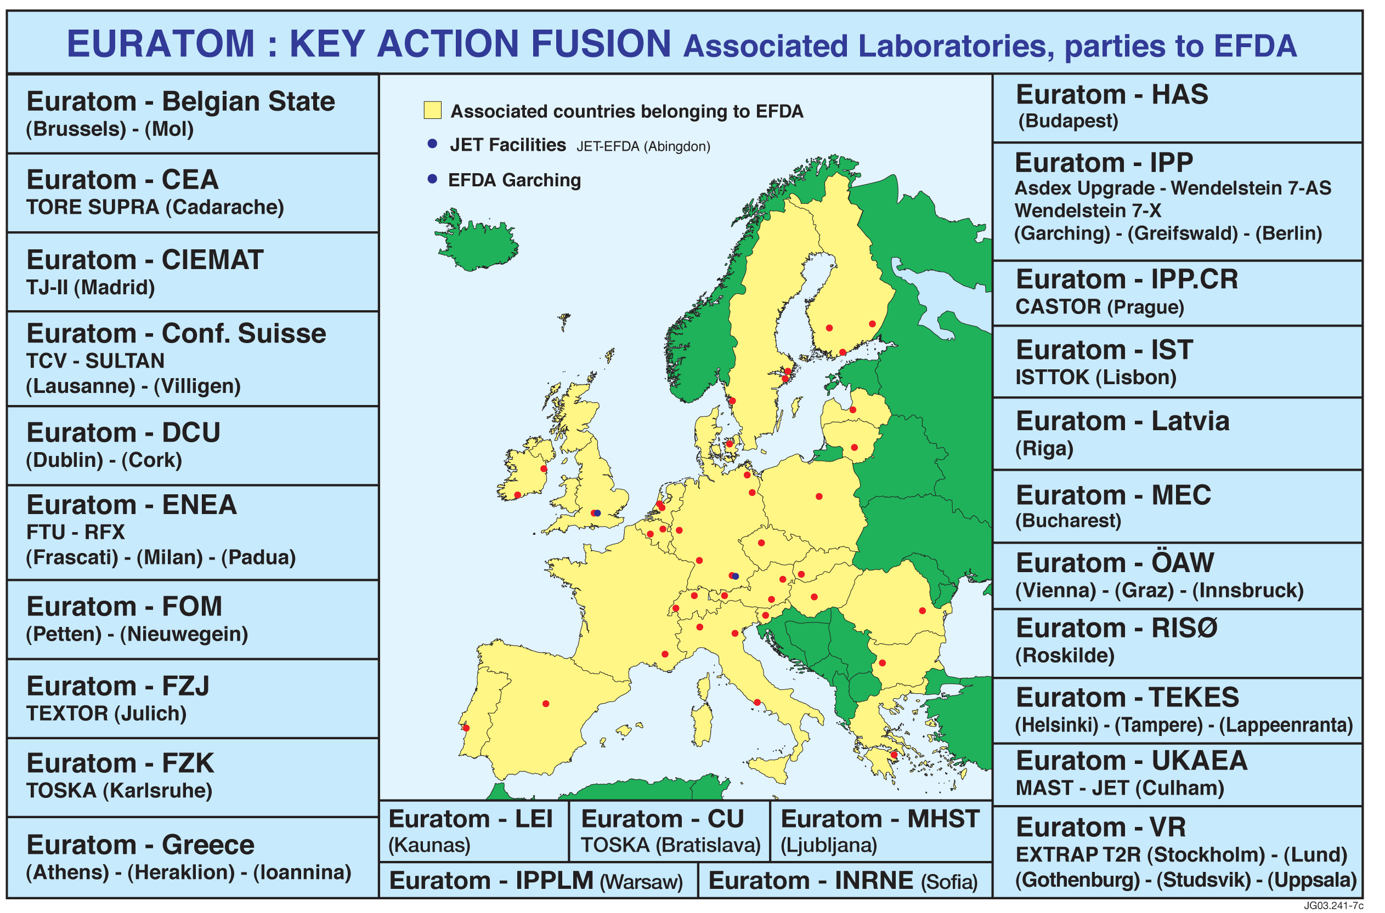

Fig. 1 EURATOM Associations participating in the European Fusion Development Agreement (EFDA)

Participation of researchers in Japanese Universities, NIFS and fusion related research institutes to JT-60 research is possible under the Facility Utilization Program of JAERI/JAEA since 1999. The number of collaborators increased significantly, year by year as shown in Fig.2.
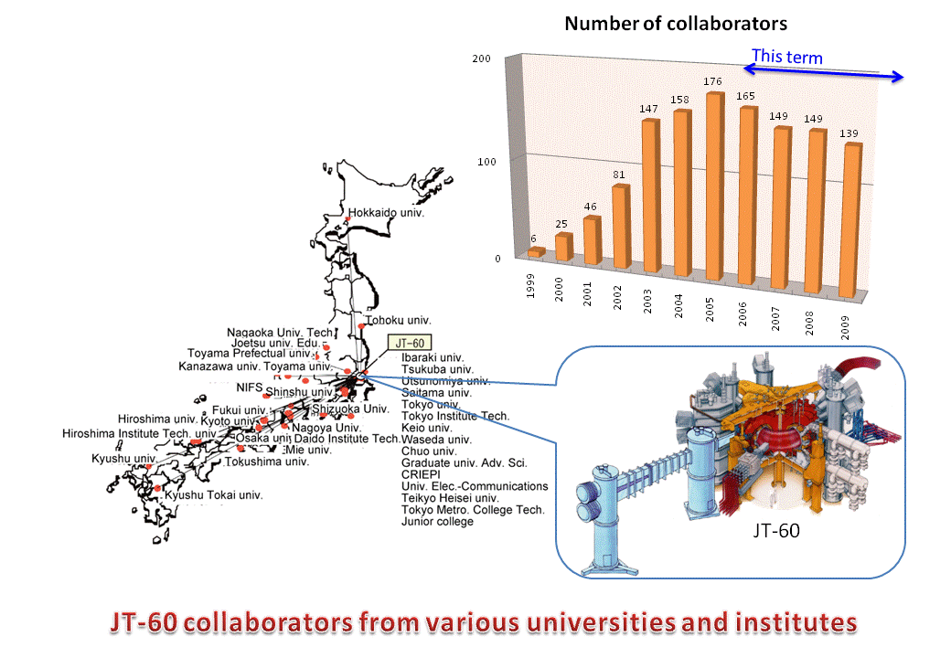
Fig. 2 JT-60 collaborators from various universities, NIFS and institutes.

The US fusion energy science program led by USDOE covers a broad range of fusion research activities including tokamak research. The following US laboratories, industry and universities are the primary collaborators in this collaboration: PPPL, GA, MIT, ORNL, LLNL, Columbia University, Lehigh University, University of Texas and University of Wisconsin. Most of these collaborate through the DIII-D, Alcator C-Mod, and NSTX programs.
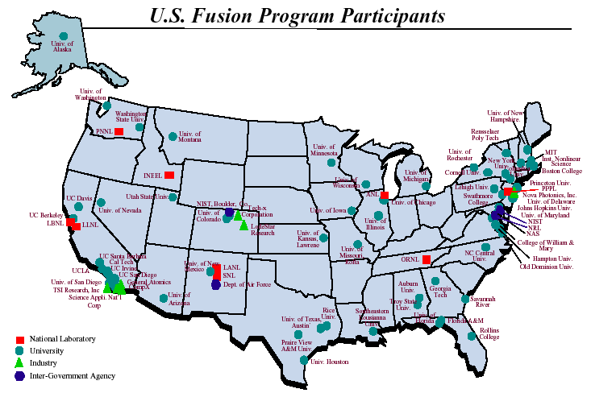
Fig. 3 All the Office of Fusion Energy Science Program participants in the United States

The National Fusion Research Institute (NFRI) is a center for joint research in Korea through collaboration between five core institutes: SNU, KAIST, KAERI, Hanyang University, and POSTECH. In addition, a number of institutes, universities and fusion-related industries have participated in the Korean domestic and ITER programs.

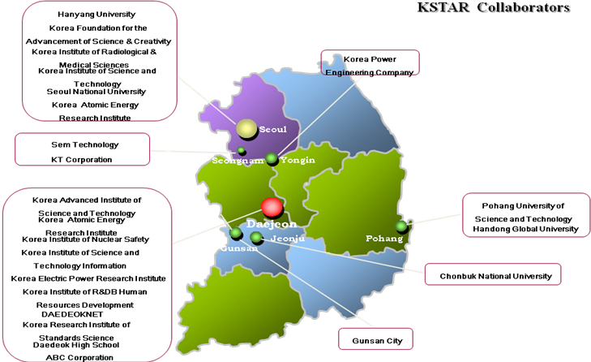
Fig. 4 KSTAR Collaborators

The Institute for Plasma Research in India, is an autonomous Physics research institute, involved in research in various aspects of plasma science including basic plasma physics, research on magnetically confined hot plasmas and plasma technologies for industrial applications. Apart from basic research, the institute is currently in the process of building a Steady State Superconducting Tokamak (SST-1).

3. Contractual and management requirements
3.1 Objectives

The objective of this IA is to enhance the effectiveness and productivity of the research and development effort related to the development of the tokamak fusion concept by strengthening cooperation on the Large Tokamak Facilities and Tokamak Programmes, and thus to provide a scientific and technological basis for the further development of the tokamak concept.

3.2 Executive committee meetings

Meeting | Quantity | Participants
Executive Committee meetings | 1.2/year | 77%

The Executive Committee (ExCo) met at least once/year on:

May 9-10, 2005, Princeton Plasma Physics Laboratory, for its annual meeting (20th)
- The Committee elected E. Oktay as the Chairman until the next meeting.
- It was announced that Dr. J. Willis had been replaced by Dr. D. Meade as a member and Dr. N. Sauthoff had been replaced by Dr. E. Marmar as an alternative member.
- It was reported that three workshops had been carried out. The total number of Personnel Assignments completed in the period was 24, 23 of which were for review tours (less than 4 weeks). Subjects are summarized as follows: 2 on Task1: Transport and ITB Physics (8%); 0 on Task 2: Confinement database and modeling (0%); 7 on Task 3: MHD, disruptions and control (19%); 5 on Task 4: Edge and pedestal physics (21%), 2 on Task 5: SOL and divertor physics (8%), 4 on Task 6: Steady State Operation (17%), 0 on Task 7: Tritium and RH Technologies (0%), and 4 on Task 8: Other (17%).

June 28-29, 2006, Cadarache, France, for its annual meeting (21st)
- The Committee elected Dr. F. Romanelli as the Chairman until the next meeting.
- Dr. D. Meade had been replaced by Dr. R. Hawryluk as a US member, Dr. J. Pamela had been replaced by Dr. F. Romanelli as an EU member, Dr. Y. Miura had been replaced by Dr. S. Ishida as a JA member, and Dr. T. Fujita had been replaced by Dr. H. Kimura as a JA alternate member.
- Some ITPA inter-machine experiments needed to be defined better. In order to achieve high priority on any device, well-defined proposals were required.
- The Chairman of the IEA Large Tokamak Executive Committee was invited to ask the Chair of the ITPA Coordinating Committee to distribute the proposals for inter-machine experiments in 2007 to the tokamak leaders by November 17, 2006.
- The meeting understood that the Chair of the ITPA Coordinating Committee would provide a list of Contact Persons.
- Collaboration on rotation studies on DIIID and JT-60U were productive in many areas utilizing co- and counter-NB injection.
- US participation in JET with diagnostics contributions had been successful. Such diagnostics-based collaboration with JT-60U was encouraged.
- It was reported that two Workshops had been carried out. The total number of Personnel Assignments completed in the period was 17, all of which were review tours (less than 4 weeks). Subjects are summarized as follows: 4 on Task1: Transport and ITB Physics (23.5%); 0 on Task 2: Confinement database and modeling (0%); 2 on Task 3: MHD, disruptions and control (11.8%); 2 on Task 4: Edge and pedestal physics (11.8%), 2 on Task 5: SOL and divertor physics (11.8%), 0 on Task 6: Steady State Operation (0%), 1 on Task 7: Tritium and RH Technologies (5.9%), and 6 on Task 8: Other (35.2%).

May 21-22, 2007, Naka, Japan, for its annual meeting (22nd)
- The Committee elected Dr. M. Kikuchi as the Chairman until the next meeting.
- Dr. R. Stambaugh had been replaced by Dr. T. Taylor as a US alternative member, Dr. S. Ishida had been replaced by Dr. Y. Kamada as a JA member, and Dr. H. Kimura had been replaced by Drs. Y. Koide and S. Ide as JA alternative members.
- The establishment of a single tokamak-related IA was considered for multilateral exchanges, enabling collaboration in experimental and theoretical tokamak research (1, 2). This IA would consolidate the activities of the present LT, PD and TEXTOR IAs and could provide a legal framework for voluntary tokamak research activities for ITER and next-step facilities worldwide, such as currently defined by the ITPA. The structure of collaboration activities could be organized according to topics. It may be preferable to implement hardware exchanges, including diagnostics and related Personnel Assignments, under separate bilateral agreements between Parties. (1) The present LT, PD and TEXTOR IAs expire before 2012. (2) Collaboration with alternative concepts on tokamak-specific issues is welcome under this IA.
- It was reported that two Workshops had been carried out. The total number of Personnel Assignments completed in the period was 21, all of which were review tours (less than 4 weeks). Subjects are summarized as follows: 2 on Task1: Transport and ITB Physics (10%); 0 on Task 2: Confinement database and modeling (0%); 6 on Task 3: MHD, disruptions and control (28%); 2 on Task 4: Edge and pedestal physics (19%); 0 on Task 5: SOL and divertor physics; 5 on Task 6: Steady State Operation (24%); 0 on Task 7: Tritium and RH Technologies; and 4 on Task 8: Other (19%).

June 3-4, 2008, General Atomics, San Diego, for its annual meeting (23rd)
- The Committee elected Dr. E. Oktay as the Chairman until the next meeting.
- Dr. M. Kikuchi had been replaced by Dr. M. Mori after 23rd ExCo meeting. Dr. S. Clement-Lorenzo had been replaced by Dr. R. Giannella.
- The ITER issues in terms of programs on Plasma Facing Component materials and experiments in each device were reported; C-Mod results (E. Marmar), AUG results (J. Schweinzer), JET plans and preparations for the ITER-like wall project (M. Watkins). Also issues in terms of international plan for ELM-Control studies were reported by M. Wade (for A. Leonard). Furthermore, experiments for the last operational campaign on JT-60U, including present plans and schedule, were reported by M. Kikuchi.
- It was reported that two Workshops had been carried out. The total number of personnel assignments completed in the period was 25, one being a participation tour (more than 4 weeks), and the others being review tours (less than 4 weeks). Subjects are summarized as follows: Task 1 (Transport and ITB Physics) was 4 (16%); Task 2 (Confinement database and modeling) was 1 (4%); Task 3 (MHD, disruptions and control) was 5 (20%); Task 4 (Edge and pedestal physics) was 4 (16%); Task 5 (SOL and divertor physics) was 0 (0%); Task 6 (Steady State Operation) was 2 (8%); Task 7 (Tritium and RH Technologies) was 0 (0%); and Task 8 (Other) was 9 (36%).

May 21-22, 2009, EFDA-JET, Culham Science Centre, for its annual meeting (24th)
- The Committee elected Dr. F. Romanelli as the Chairman until the next meeting.
- Dr. M. Kikuchi has been replaced by Dr. M. Mori, and Dr. R. Nazikian has been replaced by Dr. R. Wilson.
- A general discussion on cooperation concentrated on the restructuring of the tokamak-related Implementing Agreements.
- Following a clear presentation of what is required from the Executive Committee of the LT-IA on this matter, Dr. F. Romanelli presented the latest draft of the amendments to the LT-IA which included re-naming to the "Implementing Agreement for Co-operation on Tokamak Programmes". The attendees at the Executive Committee meeting discussed extensively the draft and made suggestions for further revision.
- The Executive Committee of the LT-IA agreed that, after the meeting, the Chair would circulate the proposed amendments (incorporating the changes from the discussion at 22 May 2009) to all Executive Committee representatives. The Executive Committee representatives would then approach their respective Contacting Parties for approval of the Amendments.
- The LT Executive Committee resolved unanimously to invite the Government of the Republic of Korea, or any entity it may designate, to join the Implementing Agreement on Co-operation on the Large Tokamak Facilities as a Contracting Party.
- The LT Executive Committee unanimously resolved to request a five year extension from 15 January 2011 to 14 January 2016. The formal agreement will be sent by June 19, 2009 from each party.
- It was reported that two Workshops had been carried out. The total number of Personnel Assignments completed in the period was 27, all of which were review tours (less than 4 weeks) without any participation of more than 4 weeks. Subjects are summarized as follows: Task 1 (Transport and ITB Physics) was 6 (22%); Task 2 (Confinement database and modeling) was 1 (4%); Task 3 (MHD, disruptions and control) was 2 (7%); Task 4 (Edge and pedestal physics) was 6 (22%); Task 5 (SOL and divertor physics) was 1 (4%); Task 6 (Steady State Operation) was 3 (11%); Task 7 (Tritium and RH Technologies) was 1 (4%); and Task 8 (Other) was 7 (26%).

Dec 16, 2009, KSTAR Research Center, NFRI, Daejeon, Korea, for an Extraordinary meeting
- At its 24th Meeting on 22 May 2009, the Executive Committee of the LT-IA resolved unanimously to request a five year extension from 15 January 2011 to 14 January 2016. Furthermore, the amendments to the LT-IA, including its re-naming to the "Implementing Agreement for Co-operation on Tokamak Programmes", were discussed extensively and further amendments proposed. All amendments proposed to date were adopted, including the proposal to appoint the Secretariat on a 5 year rotation basis. The following were also agreed:
- Management of Web Server for the CTP-IA is included in the role of the Secretariat.
- EU will take the first Secretariat under the CTP-IA.
- These detailed understandings would not be described in the CTP-IA document and can be modified with the agreement of the Executive Committee.
- The discussion concentrated on the next step which was to prepare and agree on a consolidated final version, to obtain the agreement of the Contracting Parties in writing to the IEA, and to identify the Members and Alternates of the Executive Committee. The Chair was invited to consolidate the text, distribute it to the Members of the Executive Committee who should then ensure that the Contracting Parties inform the IEA of their agreement to the revised text.

May 9, 2010, Aix-en-Provence, France, for its annual meeting (25th)
- The Committee elected Dr. M. Mori as the Chairman until the next meeting.
- Dr. Myeun KWON, Dr. Yeong-Kook OH, Dr. Jin-Yong KIM, and Dr. Woong-Chae KIM are two new Executive Committee members and two new alternate members, respectively, for the MEST (designated by the Government of the Republic of Korea).
- It was noted that the Government of the Republic of Korea announced that it had accepted the invitation from the Executive Committee of the LT-IA to join the LT-IA. Furthermore, the Government of the Republic of Korea accepted the terms and conditions of the LT-IA.
- Status and remaining issues for the CTP-IA were discussed. Following a clear presentation of what is required from the Executive Committee of the LT-IA on this matter, the IEA Secretariat (C. Pottinger) presented the status of the LT-IA and the process for requesting an extension. The IEA proposed that the IA request an interim extension at the CERT meeting on 3-4 November 2010. The Executive Committee of the LT-IA preferred to present the "Requests for Extensions (RfE)" to the FPCC by written procedure so that the RfE can be made at the November 2010 CERT meeting. As there was still time before November 2010 the Executive Committee of the LT-IA decided to submit the RfE documents to the FPCC by written procedure for a final decision by the CERT at its November 2010 meeting.
- Members discussed the Criteria Table point-by-point and carried out a self-evaluation of each of the sections. Dr. R. Hawryluk took notes on member’s comments on the items for discussion for each section that will be incorporated when drafting the End-of-Term Report and Strategy Plan.
- It was agreed that the RfE documents would be drafted and distributed to members of the Executive Committee of the LT-IA for comment before end-June 2010. The final documents would be sent to the Secretariat before end-July 2010 for review by the FPCC by written procedure as soon as possible following that date.
- Should the CERT approve the request for extension for all IAs by written procedure, the IA agreed it would present the RfE to the FPCC on 15-16 February 2011 and then to the CERT at its meeting in June 2011.
- It was reported that two Workshops had been carried out. The total number of Personnel Assignments completed in the period was 25, all of which were review tours (less than 4 weeks) without any participation of more than 4 weeks. Subjects are summarized as follows: Task 1 (Transport and ITB Physics) was 6 (22%); Task 2 (Confinement database and modeling) was 1 (4%); Task 3 (MHD, disruptions and control) was 2 (4%); Task 4 (Edge and pedestal physics) was 6 (22%); Task 5 (SOL and divertor physics) was 1 (4%); Task 6 (Steady State Operation) was 3 (11%); Task 7 (Tritium and RH Technologies) was 1 (4%); and Task 8 (Other) was 7 (26%).

December 15 and 16, 2010, Cadarache, France, for its annual meeting (1st CTP-Exco)
The chair of this meeting was Dr. M. Mori (JAEA). A "Special Discussion Session on Major Machine Viewpoints and Contributions to ITER Issues in the Next Few Years" was held jointly with the ITPA. The members of the ITPA CC, the chairs, the deputy-chairs and the IO deputy chairs joined the meeting. Following the introductory remarks by Dr. R. Stambaugh, the chair of the ITPA CC, each party presented their own views and contributions to the several key issues for ITER. The issues were: ELM, Disruption, Divertor material and Heating. Also Dr. M. Watkins made a presentation on "Preparing a case for DT operation in JET in 2014-2015". In September 2010, the Chair sent a letter in which the Executive Committee unanimously requested the CERT to extend the current term of the Implementing Agreement to 30th June 2011. However, the chair received, in December 2010, an official notification which indicated that the end date of the extension approved by the CERT is not 30 June 2011 as proposed by the ExCo but 30 June 2012. US, EU and KO expressed their preference of "30 June 2012" as opposed to the original proposal "30 June 2011" in order to avoid further confusion. After discussions, the Executive Committee unanimously accepted the CERT decision to extend the current term of the Implementing Agreement to 30 June 2012.
Considering that the TASKs are closely related to the ITPA, of which results and plans are presented in the ITPA CC Meeting and the IEA ITPA Joint Experiment Planning Meeting to be held just before the CTP Executive Committee meeting, it was agreed to close all the TASKs in order to avoid unnecessary duplication. Executive annual summaries of the ITPA activities prepared by the IO deputy-chairs at the ITPA public site can be referred.
It was agreed that the chairmanship is transferred to the successor just after the FPCC meeting every year.
JA proposed to transfer the role of secretariat and the web management to EU, by the end of Dec. 2010. This proposal was agreed by the parties. EU accepted to succeed these responsibilities, but will not able to assign the next secretariat and responsible officer for the Web-management until the next FPCC meeting (Paris, 2-3 Feb. 2011).
It was explained by the chair that the list of contracting parties in the CTP IA was modified by the IEA legal office from one reviewed by the parties. It was confirmed that the EU and JA wanted the text to be corrected to that reviewed by the parties; the change does not affect the US. Dr. E. Oktay telephoned Ms. C. Pottinger during the meeting and she and the legal office confirmed that the list of contracting parties is not a part of official text and amending to the reviewed version was not a problem. The text will be amended by the legal office as appeared in the version reviewed by the contracting parties.
It was discussed to invite China, India and Russia to join the CTP IA. Although the observers from Russia informed that RF is not ready to participate in the CTP-IA at present, it was agreed that an invitation letter should be sent anyway. It was agreed that the chair will send the invitation letters to all three parties. The contact point (CP) is Dr. P. Kaw for India. Observers from China and Russia agreed to inform the names of their CPs to the chair after confirmation. Ms. C. Pottinger has copies of the invitation letters previously sent to India and China, and will send them as examples to the ExCo members.
The current status of an IEA FPCC Task group on Steady State Operations (SSO) - a joint activity among related IEA IAs on the steady-state operation was explained by Dr. E. Oktay. This topic has been under discussion at the FPCC for the past 5-6 years. Jean Jacquinot and Osamu Motojima (prior to his current position as the ITER Director General) are leading this effort. Jean Jacquinot will report on the status of this activity at the 2011 annual FPCC meeting in Paris on February 2-3, 2010. Briefly, representatives from several ExCos of IEA Implementing Agreements are to identify their representatives on this Task group and choose their Chair. Technical topical areas are being identified to develop a Work Plan for this Task Group.
The committee unanimously agreed that Dr. M. Mori will continue the chair until the next FPCC on 2-3 Feb. 2011 and also that the next chair will be Dr. M. Kwon after the FPCC.
It was agreed to keep the same style as held this time, a joint meeting with the ITPA CC and the IEA ITPA Joint Experiment planning meetings. It was agreed that the country and machine reports should be maintained and the special session can be removed. The IO agreed to host these meetings again at Chateau de Cadarache. It was agreed to reserve a period of four days (12th-15th December 2011) for the next meetings.

December 15, 2011, Cadarache, France, for its annual meeting (2nd CTP-Exco)
India has joined the IA-CTP in April 2011. China and Russia have been invited to join. The ascension of China is pending internal approval and the ascension of Russia is under discussion.
Since a framework for collaboration between ITER and other Tokamaks is needed, the ITER participation in the CTP-IA was discussed in previous occasions. The ITER DG supports ITER joining the CTP but this is being checked by the ITER legal office. There is also the need to check with the IEA legal office the possible participation of ITER in the CTP-IA. The Executive Committee Membership list was checked and revised. The delegations from the US and Korea updated their membership list and sent a revised version of the Executive Committee Membership to the Secretary as follows: Francesco Romanelli (EU Member), Ruggero Giannella (EU-Member), Duarte Borba (EU-Alternate), Hartmut Zohm (EU-Alternate), Predhiman Krishan Kaw (IN-Member), R. Jha (IN-Member), Masahiro Mori (JP-Member), Yutaka Kamada (JP-Member), Yoshihiko Koide (JP-Alternate), Kouji Shinohara (JP-Alternate), Naoyuki Oyama (JP-Alternate), Jong-Gu Kwak, (KO-Member), Yeong-Kook Oh (KO-Member), Jin-Yong Kim (KO-Alternate), Woong-Chae Kim (KO-Alternate), Steve Eckstrand (US-Member), Randy Wilson (US-Member), Earl Marmar (US-Alternate), Punit Gohil (US-Alternate), Mickey Wade (US-Alternate).
Regarding the workshops planned for 2012, it was commented that it is difficult to organise further workshops in even years in addition to the already planned joint experiments workshop in Cadarache in December 2012. Nevertheless, it was suggested to organise a workshop on ELMs in 2013.
The Chair made a presentation on the process for the CTP-IA 5 year extension request. The 6 year report, the 5 year strategic plan and the criteria questionnaire table need to be finalised by the end of December; and the preparation of these documents were discussed at the meeting. A number of comments were collected and the secretary will implement them and circulate them for approval by e-mail. These include the need to update the documents to reflect the fact that India has joined in April 2011, therefore, a description of the Indian fusion programme is required. Also, an explanation for the closure of the tasks as it was agreed in 2010 is needed. The changes regarding the fact that the new CTP-IA has replaced the LT-IA need to be incorporated. The report from each party needs to be updated taking into account this year’s (2011) report. The 5 year Work Plan will need also, a reference to the DEMO programme. Jong-Gu Kwak will provide a text on DEMO for the 5 year Work Plan. The description should not be too detailed, since each party has each own specific DEMO road map. This input should be provided by Wednesday 21st December 2011.
The CTP-IA implementing agreement website is now under the responsibility of the EU and it will be hosted at JET, Culham, UK. The new website will be available from January 2012.
A discussion took place on the data policy for the data from Tokamaks collected under CTP or other bi-lateral agreements. The data belongs to the Tokamaks, but it is proposed that the use of the data will be governed under the terms of the ITER agreement. It was agreed that Yutaka Kamada will distribute a draft document on this matter. This proposal will be submitted for consideration by the CTP-IA executive committee members. The proposal should provide the rational for governing the ITPA data under the ITER agreement. In addition, the members of the CTP-IA will discuss this matter with the legal experts. A proposal was made to have the ITPA Coordinating Committee Meeting, the CTP-ITPA Planning Meeting for Joint Experiments (JEX) and the Executive Committee Meeting of CTP-IA in 3 days, instead of 4 days. This proposal was accepted and the date of these meetings was provisional agreed for the 10-12 December 2012 in Cadarache. This to be confirm after the confirmation of the date of the ITER summer school in India in December 2012.
Steve Ecktrand (US) was elected the new chair for the one year term of 2012.

3.3 Annual reports

The Executive Committee shall provide the IEA with reports containing technically substantive, non-proprietary information on the progress of the Programme and its results. At the 33rd FPCC meeting on January 21-23, 2004, the reporting format for the Annual Report changed as follows:

ANNUAL REPORTS would be drafted according to the following structure:
- Executive Summary (1-2 pages including the following key elements):
- Short description of the IA mission and relevance to the international fusion program;
- Current focus and objectives (main topics);
- Past achievements/accomplishments (main topics);
- Future strategy/plans (main topics);
- Collaborations in place in/outside the IEA;
- Message to policy makers.
- Attachments:
Current activity and past achievements/accomplishments (details)
Future strategy/plans (details)
Any other attachments that the Executive Committee may wish to add (lists of members, meetings, publications)

In addition, the annual reporting period for the LT-IA was changed to June-to-June for 2004 and onwards. Accordingly, the Annual Reports have been submitted to the IEA.
Information on the Annual Reports has been provided to the public through the website of the LT-IA..

3.4 IA legal text
As mentioned in Section 1 ‘Strategic direction’, coordination with other bodies has already been expanded significantly since 2002 to include other tokamak-related IEA IAs (Poloidal Divertor and TEXTOR). In order to further improve the efficiency of the cooperation with other tokamak-related IAs, discussions in the IEA Fusion Power Coordinating Committee (FPCC) and the Executive Committees of the three IAs on ‘re-structuring’ the tokamak related IAs continued over the past ~ 5 years, leading to a consensus to amend the LT-IA to a single “Implementing Agreement for Co-operation on Tokamak Programmes (CTP-IA)” that would be open for the participation of major tokamaks in the ITER Members. Since the CTP-IA includes all activities under the IA for Poloidal Divertor (the PD-IA), the Executive Committee of the PD-IA decided not to request a further extension of its IA, which expired in July 2010. Korea, which had participated in the PD-IA but not in the LT-IA, joined the LT-IA on 5 February 2010 in order to ensure a smooth transition to the single CTP-IA. The legal text of the CTP-IA was finalised, and it became effective in June 2010 with the assent of all Contracting Parties, following the procedures defined in the LT-IA and the IEA Framework. India joined the CTP-IA in April, 2011.

4. Contribution to technology evolution / progress
4.1 Progress made by Task activities
The Executive Committee decided to use the ITPA Topical Group Structure for organizing the joint research activities under this IA, namely, the eight task activities:
Task 1: Transport and ITB Physics
Task 2 : Confinement database and modelling
Task 3 : MHD, disruptions and control
Task 4 : Edge and pedestal physics
Task 5 : SOL and divertor physics
Task 6 : Steady State Operation
Task 7 : Tritium and RH Technologies
Task 8: Other

However, considering that the TASKs are closely related to the ITPA, of which results and plans are presented in the ITPA CC Meeting and the IEA ITPA Joint Experiment Planning Meeting to be held just before the CTP Executive Committee meeting, it was agreed to close all the TASKs in order to avoid unnecessary duplication. Executive annual summaries of the ITPA activities prepared by the IO deputy-chairs are available in the ITPA public site.

4.2 Progress in each Contracting Party supported and enhanced by this cooperation

During this term, JT-60, JET, US fusion energy science and KSTAR made significant progress in tokamak research supported and enhanced by this cooperation. The scientific progress was motivated through impressive collaboration and healthy competition towards advancing fusion energy science.

JT-60 has achieved significant progress towards ITER and DEMO. In the positive magnetic shear regime, high β_{N}H_{H98(y,2)} of 2.6 with β_{N} ~ 2.6 and H_{H98(y,2)} ~ 1 was sustained for 25 s (~14τ_{R}). In the weak magnetic shear regime, high β_{N} ~ 3 exceeding the ideal non-wall MHD limit (β_{N}^{no-wall}) was sustained for ~5 s (~3τ_{R}) with RWM (resistive wall mode) stabilization by toroidal rotation. In the reversed magnetic shear regime, high β_{N} ~ 2.7 (>β_{N}^{no-wall} ) with q₉₅ ~ 5.3, H_{H98(y,2)} ~ 1.7 and f_{BS} ~ 0.9 was obtained. These plasma parameters almost satisfy the requirement of ITER steady-state scenario. JT-60U discovered the EWM (energetic particle driven wall mode) in the high beta regime >β_{N}^{no-wall}. A systematic study on rotation revealed the minimum toroidal rotation required for stabilizing RWM, effects of rotation on the pedestal height, type I ELM size, grassy ELM size, ITB (internal transport barrier) strength, heavy impurity accumulation and diffusion / pinch of momentum. The intrinsic toroidal rotation driven by the ion pressure gradient and by the ECH was confirmed. The effects of toroidal field ripple on the pedestal characteristics were clarified by separating the effects of rotation. The dedicated H-mode and pedestal experiments indicate that the pedestal width scaling of Δ_{ped} = 0.315aρ*_{pol}^{0.2}β_{pol}^{0.5}. The active NTM (neoclassical tearing mode) stabilization system using modulated ECCD, which is synchronized to rotating island, was developed and the efficiency of modulated ECCD in m/n = 2/1 NTM stabilization was demonstrated. As for the JT-60SA programme being promoted jointly by Japan and EU, nine procurement arrangements for the Japanese contributions (76% of the total Japanese procurement cost) have been launched between the Implementing Agencies, JAEA and F4E by November 2011. Twenty-four of sixty-two EF (equilibrium field) superconducting conductors and six of twenty-eight CS (center solenoid) superconducting conductors have been successfully provided in JAEA Naka Institute, and manufacture of nine (out of ten) pancakes for the EF4 coil has been completed at the manufacturer’s factory by November 2011. Two 40 degree sectors of the vacuum vessel have been successfully manufactured in JAEA Naka Institute. The earthquake had made no serious damages to the facilities and equipments to be utilized for JT-60SA. Seven procurement arrangements (66% of the total European procurement cost) for the European contributions have also been signed by November 2011, including TF coil manufacture. The JT-60SA Research Plan has been discussed widely both in JA and EU fusion research communities, and the Version-3 will be completed by the end of 2011 with approximately 230 co-authors (150 from 15 JA laboratories, 80 from 21 EU laboratories).

JET focuses strongly on ITER component design, ITER operating scenario preparation and physics issues essential to efficient ITER exploitation. Up to 60% of run-time has been devoted to ITPA ITER high priority coordinated experiments, including cross-machine studies with JT-60U, DIII-D, ASDEX Upgrade and C-Mod. JET contributed to ITER ICRH design by demonstrating ELM tolerance with 3 different ICRH systems; up to 8.5MW RF power coupled to ELMy H-modes; high voltage (42kV) and power density (6.2MW/m²); 30-40% heating efficiencies with fundamental H and second harmonic ³He heating in hydrogen plasmas, thus providing data for verifying ICRF models of non-active phase ITER operation; and Ion Cyclotron Wall Cleaning under ITER-relevant conditions. LH coupling was demonstrated at ITER-relevant power densities (24.1MW/m², scaled for 3.7GHz). ICRH and LHCD coupled at long distance (~0.15m) and high δ, as required for ITER. JET contributed to ITER coil set and divertor design modifications by verifying ITER baseline scenario from start to finish in D₂ and ⁴He, clarifying influence of plasma shape and current rise heating. P_{L-H} similar in D and ⁴He, thus opening possibility for ITER H-mode studies in ⁴He; confinement appears lower in ⁴He. Stationary ELMy H-modes up to 4.5MA/3.4T showed H₉₈~0.9 for P_{in}<2.2P_{L-H}. TF ripple studies with low edge ν* showed adequate confinement in ITER requires <0.5% ripple amplitude, preferably 0.2-0.3%. ELM mitigation techniques (RMPs, kicks, pellets) can increase ELM frequency by 3-5, but not yet to level required for ITER; complete ELM suppression was not observed; IR measurements show only 30-40% reduction in ELM associated peak heat loads on outer divertor. Pellets trigger ELMs only when sufficiently large (and fast) to penetrate to top of Edge Transport Barrier (ETB). Extrinsic impurity seeding (Ne or N) reduced inter-ELM power loading to ~1MWm⁻² for only ~10% loss in energy confinement. Asymmetric (sideways) force measurements during disruptions led to ITER Vacuum Vessel support structures being changed; transient heat loads were reduced by Massive Gas Injection (50% heat load reduction during thermal quench); techniques for run-away electron generation, control and suppression were studied. All ITER normalised conditions relevant for steady state operation (β_{N}=2.7, H₉₈=1.2-1.3, T_{e}=T_{i}, f_{bs}~0.4, f_{GW}~0.7, but not ρ*) have been achieved. Discharges with Internal Transport Barriers (ITBs) were extended to high power (32MW), T_{i}~T_{e}, high core and edge densities. Active ELM control with >30MW and extrinsic Ne seeding reduces divertor heat loads. Hybrid discharges, matched to AUG/DIII-D, extend to H₉₈~1.4 and ρ*=0.005 at high triangularity and 2.4T, and to 20s with NB injection of 186MJ. Temperature profiles and plasma performance independent of heating mix (NB/ICRH), despite strongly reduced (5-10) toroidal rotation and dominant electron heating with ICRH. Ion temperature critical gradient length "threshold" for anomalous transport determined and inward momentum pinch measured. ETB width (T_{e} and n_{e}) normalised to minor radius shows no strong ρ* dependence, thus excluding a narrower pedestal in ITER. Heat diffusivity reduced in narrow ITB layer either side of which modulated ICRF power was deposited. Localised Alfvén cascades observed with X-mode reflectometry determined location of q_{min}. Fast ions affect directly sawtooth stability, thus being beneficial for control in ITER. Scintillator probes measured velocity distribution of MHD-induced fast particle losses. Material migration and fuel retention were quantified for C Wall and divertor. Fusion Technology tasks concentrated on tritium in tokamaks, tritium process and waste management, plasma facing components, engineering, neutronics and safety. Following the successful start up of JET in 2011 after the shutdown to install the ITER-like Wall, JET now operates using the ITER combination of first wall materials (W divertor and Be wall) and a NB Power Upgrade aiming at (34MW/20s).

The ASDEX-Upgrade Tokamak in Garching showed n=2 ELM suppression, with 2 x 4 off midplane coils. FIRE (Fast Injection by Rupture disk Explosion Technique) for disruption mitigation has been successfully developed in Tore-Supra (Cadarache). In TCV, Sawtooth pacing was achieved, when Sawtooth-stabilizing ECCD is removed at a pre-defined time since the last crash, triggering the next crash. ELM mitigation was also achieved by operating at negative triangularity. In MAST, experiments with different resonant magnetic perturbations showed mitigation of ELMs, but no suppression was achieved so far.

In the U.S. fusion program, progress has been made on the three large facilities, C-Mod, DIII-D and NSTX. Notable achievements on C-Mod include: (a) observation of strong toroidal rotation generated by the plasma itself even in the absence of external torques; (b) elucidation of the role of turbulent cross-field transport in a wide range of plasma edge and divertor phenomena including the plasma density limit; (c) development and investigation of an operating regime (I-mode) with H-mode like energy confinement, L-mode like particle confinement and no large ELMs; (d) studies of disruption mitigation via massive injection of inert gases found an optimal mix of helium and argon, which provided both a fast response and large decrease in halo currents and other disruption effects. Notable achievements on DIII-D include: (a) suppression of ELMs by resonant magnetic perturbations induced by internal coils; (b) demonstration of Resistive Wall Mode stabilization beyond the no-wall limit using active feedback control; (c) development of steady state and hybrid plasma scenarios that match the performance requirements of ITER, (d) discovery of the Quiescent H-mode ELM-free regime (QH-mode), and (e) detailed tests of physics models describing key aspects of transport, stability, and energetic particle behaviour. A series of validation experiments confirmed the off-axis deposition, heating, and current drive of the off-axis NBI. Off-axis NBI was then utilized to extend the operational space and performance of steady-state advanced Tokamak scenarios. Stationary discharges with qmin > 2, betaN = 3 were achieved, limited by the available co-NBI power. Notable achievements on NSTX include: (a) Dynamic error-field correction and n=1 RWM control to maintain plasma rotation and sustain high normalized beta (4.5-6) above the no-wall limit for multiple plasma current redistribution times; (b) active suppression of the n=1 RWM at low ITER-relevant plasma rotation (obtained with n=3 non-resonant braking) was achieved with active feedback control. (c) observation that lithium coatings reduce recycling, lower the early plasma density, increase the thermal confinement, and can eliminate ELMs via reductions in the pedestal density gradient. (d) observations that non-linear mode-coupling between Alfven Eigenmode (AE) instabilities (also known as “avalanches”) can lead to substantial fast-ion transport and loss, and (e) observations of Electron Temperature Gradient (ETG) turbulence.

Beginning with the successful achievement of the first Plasma generation in 2008, the 2nd operation and the 3rd operation campaigns were completed successfully with significant upgrades of the KSTAR device. To achieve D-shaped, diverted plasmas, all of the Plasma Facing Components (PFCs) including the divertor were installed inside the vacuum vessel. The sixteen-segmented In-Vessel Control Coils (IVCCs) were also installed behind the PFCs. The IVCCs will form two sets of circular vertical and radial position control, and twelve picture-frame coils for RWM/FEC control. The first NBI system, designed to deliver 8MW with three ion sources, was commissioned during the 3rd campaign. During the 4th campaign of KSTAR in 2011, emphasis was placed on active ELM control using various methods such as: non-axisymmetric (NA) magnetic perturbations, supersonic molecular beam injection (SMBI), vertical jogs of the plasma column, and edge electron heating. By applying n=1 NA field, different ELM control effects were observed: from the full suppression of ELMs to even the excitation of ELMs depending on the poloidal phasing of NA field coils. The Korean R&D in fusion energy is supported by the ‘Fusion Energy Development Promotion Law, legislated in 2007.

The repair and refurbishment of the SST-1 machine has been completed. All magnets and current leads have been individually tested at 4 K. Machine assembly is in progress and engineering commissioning will commence soon. Recent Experiments in the ADITYA Tokamak have focussed on Electrode Biasing experiment and LH transition; RF heating experiments with ICRH and pre-ionization experiments in support of SST-1 plasma Initiation.

5. Policy relevance
This implementing agreement is one of the most active fusion IAs under IEA. Through the LT-IA and now under the CTP-IA, the productivity of the large tokamaks such as JT-60 and JET has been enhanced significantly; the fusion energy science programme of the US has both contributed and benefited; and the recent participation of the Korean tokamak programme is of benefit to all participants by the operation of KSTAR. The cooperation has contributed to the success of the large tokamaks in demonstrating equivalent break-even conditions and significant DT fusion power production and thus contributed to advancing the implementation of the international large scale fusion project, ITER. Thus, the LT-IA has contributed significantly to the international political decision of implementing the ITER Project in 2006 and now under the CTP-IA, continues to contribute to the ITER Council’s political decisions for the management of the ITER Project.

6. Contribution to information dissemination

The most important activity of this cooperation is the publication of papers to document the progress of the research. Participants of this activity are encouraged to acknowledge the CTP-IA. Also, a website for the CTP-IA provides information about the activities.

  - Increased visibility through the LT-IA/CTP-IA Website during the period from 2006 to 2010 hosted by Japan and CTP-IA Website hosted by the EU from 2012 onwards.

The IEA Large Tokamak Implementing Agreement (LT-IA) is one of the few Implementing Agreements that has a complete website including presentations, etc.. At the request of the FPCC at its meeting on 30 January 2003, the Executive Committee of the LT-IA decided to develop a website to increase its visibility to the public.
The LT-IA Homepage has been hosted by Japan until 2011at http://www-jt60.naka.jaea.go.jp/lt/, and from 2012 onwards the website will be hosted by the EU at http://ctp.jet.efda.org/lt. The website with the IEA LOGO comprises a free access section and a section for “Internal use only”. In the free access section, the history, annual reports, Executive Committee members, task structure, etc. are available to the public. Access to the “Internal use only” section containing materials presented at meetings of the Executive Committee, Workshop materials, and Personnel Assignments is restricted to the members of the Executive Committee. The top page of the website as at the end of 2010 is shown below. The website has been updated so that new information is provided.
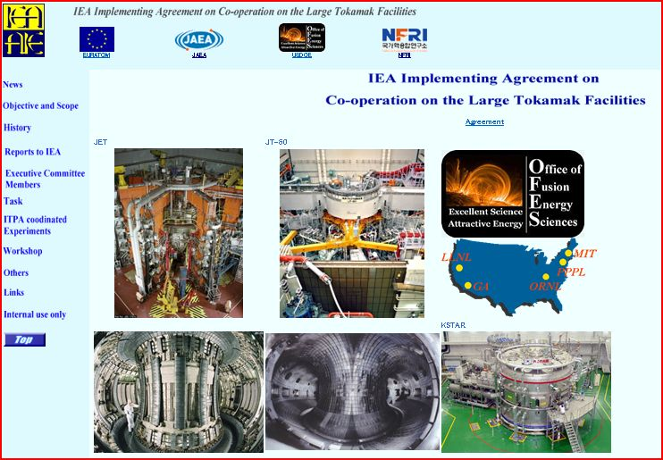
Fig. 5 Top page of IEA LT website at the end of 2010

6.2 Publications during this term
The number of publications during this term (January 15, 2006 to January 14, 2011) which are related to the LT-IA is 148 (as of June 2010) as shown in Table 4.

Table 4 The number of publications for each Task (as of June 2010)
Task 1: Transport and ITB Physics | 23
Task 2: Confinement database and modeling | 8
Task 3: MHD, disruptions and control | 8
Task 4: Edge and pedestal physics | 18
Task 5: SOL and divertor physics | 16
Task 6: Steady State Operation | 22
Task 7: Tritium and RH Technologies | 16
Task 8: Other | 37

7. Outreach to IEA non-Member countries
Coordination with other bodies had already expanded significantly since 2002 to include other tokamak-related IAs (Poloidal Divertor and TEXTOR), technology-related IAs (Environment & Safety), International Tokamak Physics Activity (ITPA) and other international tokamak programs in China, India and Russia, IEA non-Member countries, through several appropriate bilateral agreements.
Coordination with ITPA involves mainly the planning and implementation of joint experiments on several devices with prescribed parameter ranges and conditions in order to investigate specific physics issues that would benefit from comparative studies. Such joint experiments are recommended by several Topical Physics Groups of the ITPA and address High priority research for ITER. Thus, this activity adds significant value to the collective results from different programs and advances the physics basis of ITER. The coordination with the ITPA was initiated by the Executive Committee of the LT-IA at its annual meeting in June 2002. The first planning meeting for this ITPA/IEA Coordination was held at MIT in November 2002, and subsequent meetings have been held each year. While the first planning meeting was conducted by the LT-IA, the subsequent meetings were organized jointly by the three tokamak-related IAs, and have included participants from China, India and Russia who collaborate under the framework of appropriate bilateral agreements. The results obtained in ITPA activities have been published in journals, IAEA Conferences and Workshops, etc..

During the term of the LT-IA covered by this Report, the Executive Committees for the LT-IA and the PD-IA agreed to merge activities under a single IA for more efficient coordination. Accordingly, the Executive Committees amended the LT-IA so that it became the single IA for Co-operation on Tokamak Programmes (CTP), covering also the activities of the PD-IA. In order to ensure a smooth transition, the Government of the Republic of Korea, one of the contracting parties of the PD-IA, joined the LT-IA on 5 February 2010, with the MEST being its designated authority. The amendment became effective on 15 June 2010.

Other ITER Parties such as India, China and Russia were invited to become members of CTP-IA according to the decision made at the CTP-IA CC meeting in 2010. India finished the necessary procedure to become a member in April 2011. China is waiting for the government approval and Russia is under the preparation process.

8. Added value
Coordination with the ITPA involves mainly the planning and implementation of joint experiments on multiple devices with prescribed parameter ranges and conditions in order to investigate specific high-priority physics issues for the ITER project and DEMO concepts that would benefit from comparative studies. Since these can only be carried out internationally, the LT-IA and now the CTP-IA has provided valuable opportunities for its Contracting Parties to increase the reliability of plasma performance prediction. This means that the joint experiments by which the reliability of prediction has been improved indisputably contribute to reducing research costs necessary for obtaining the required result.

